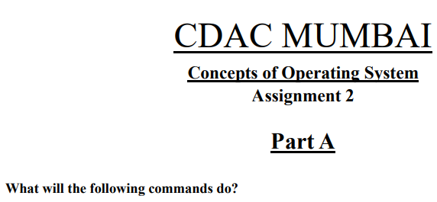

**• echo "Hello, World!"**

Print the “ Hello, World! “

**• name="Productive"**

Assign string "Productive” to name in shell

**• touch file.txt**

Create a new file “file.txt”

**• ls -a**

List all the content of the current directory including hidden files.

**• rm file.txt**

Delete the file “file.txt”

**• cp file1.txt file2.txt**

Copy file1 content into file2

**• mv file.txt /path/to/directory/**

Moving file.txt to the given destination.

**• chmod 755 script.sh**

Modify the permission as user can read, write and execute, group and others can only

read and execute the file script.sh.

**• grep "pattern" file.txt**

Search for word ”pattern” in file.txt

**• kill PID**

Used to kill the process with specific ID.

**• mkdir mydir && cd mydir && touch file.txt && echo "Hello, World!" > file.txt && cat file.txt**

Makes a directory named mydir and open it then creates a file named file.txt and writes

Hello, World in that file and open the file.txt to show the content in it.

**• ls -l | grep ".txt"**

List out all the file having.txt extention in the end with all their information.

**• cat file1.txt file2.txt | sort | uniq**

Open up both the files and shows the different content of them.

**• ls -l | grep "^d"**

List out all the directories with their information.

**• grep -r "pattern" /path/to/directory/**

Searches recursively for the string "pattern" within all files in the specified directory

and its subdirectories.

**• cat file1.txt file2.txt | sort | uniq –d**

Open up both the files and shows the duplicates content of them.

**• chmod 644 file.txt**

Modify the permission as user can read and write, group and others can only read the

file.

**• cp -r source_directory destination_directory**

Copy all the content including subdirectories and files from source_dir to

destination_dir.

**• find /path/to/search -name "*.txt"**

Find the files having “.txt” extention in the specified path.

**• chmod u+x file.txt**

Modify the permission for owner i.e. he can now execute the file.txt.

**• echo $PATH**

Used to display the current value of the PATH environment variable in your shell.

**PART - B**

**Identify True or False:**

1. **ls** is used to list files and directories in a directory. **true**

2. **mv** is used to move files and directories. **true**

3**. cd** is used to copy files and directories. **false**

4. **pwd** stands for "print working directory" and displays the current directory. **false**

5. **grep** is used to search for patterns in files. **true**

6. **chmod 755 file.txt** gives read, write, and execute permissions to the owner, and read and execute permissions to group and others. **true**

7. **mkdir -p directory1/directory2** creates nested directories, creating directory2 inside directory1 if directory1 does not exist. **true**

8. **rm -rf file.txt** deletes a file forcefully without confirmation. **True**

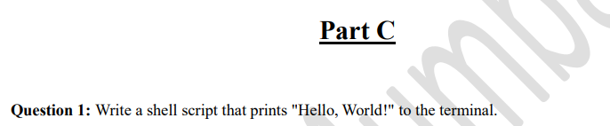

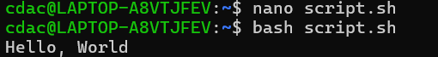



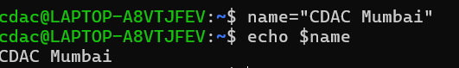



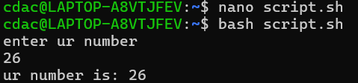



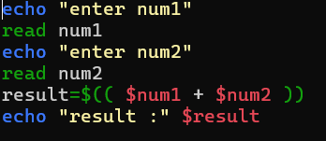

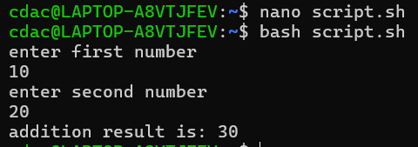



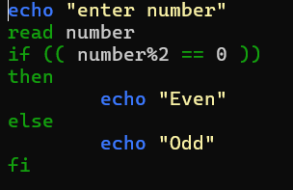

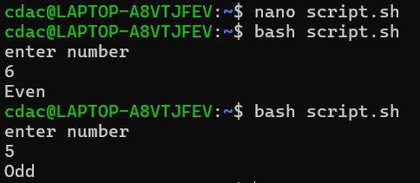



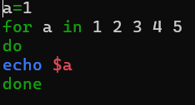

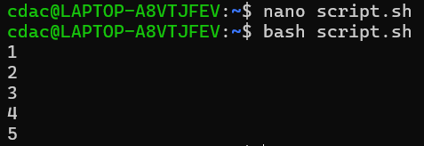



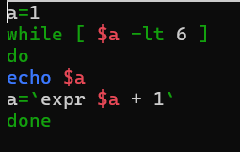

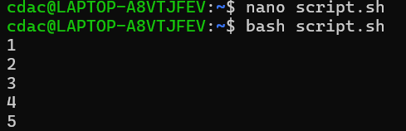



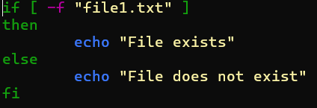

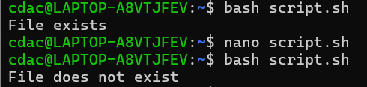



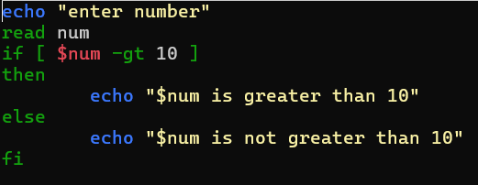

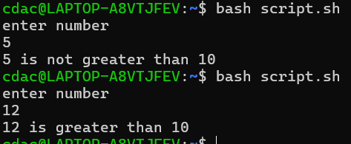

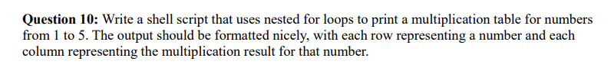

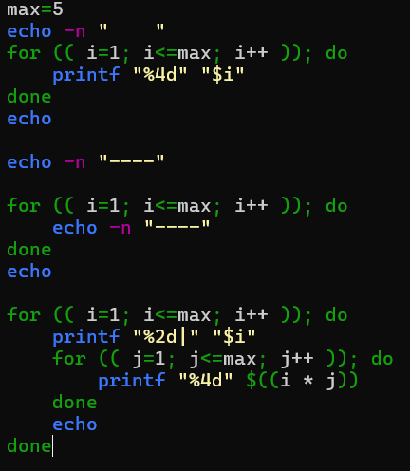

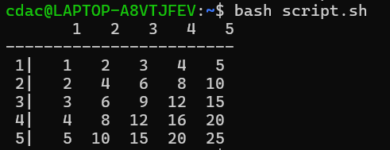



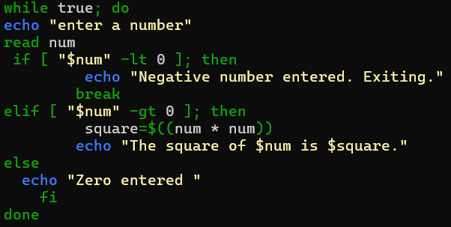

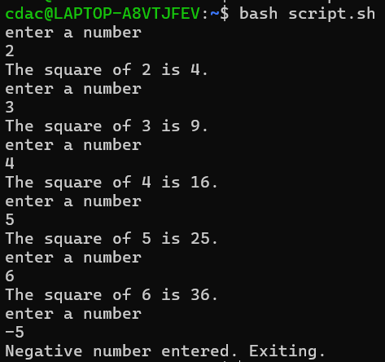

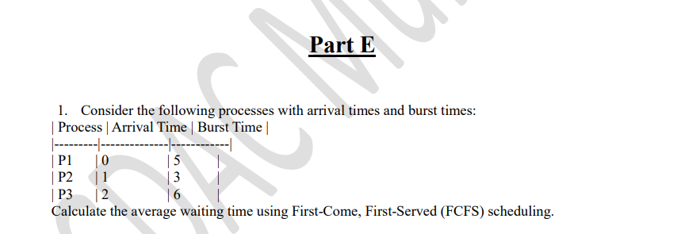

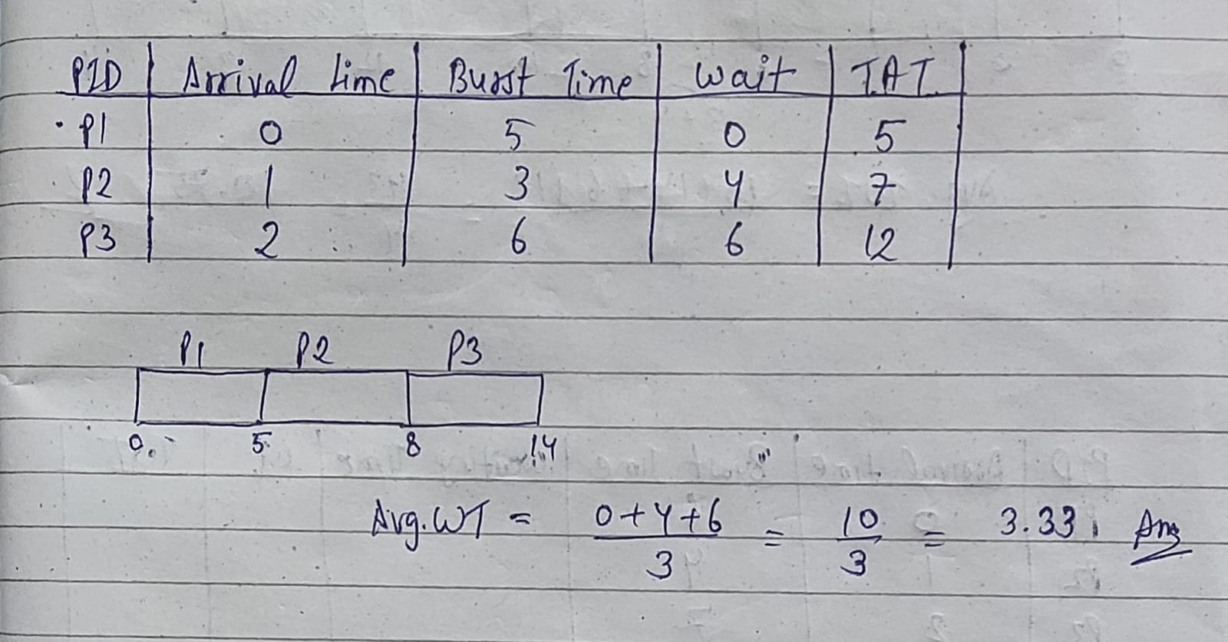

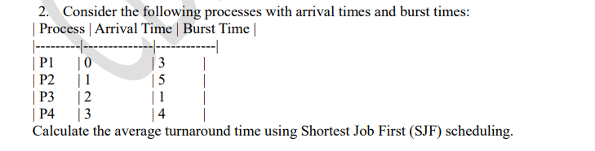

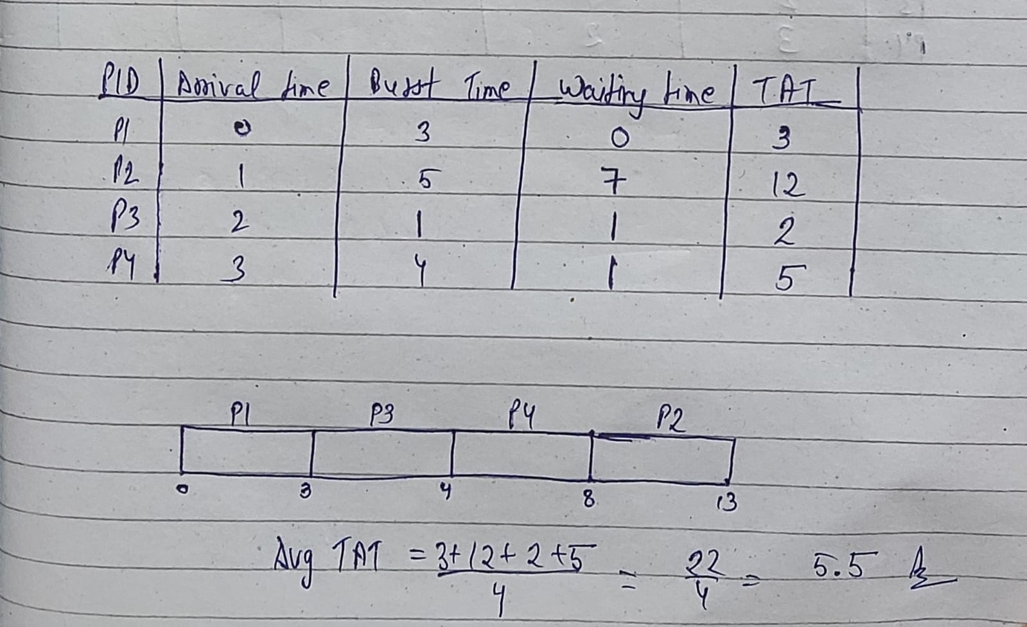

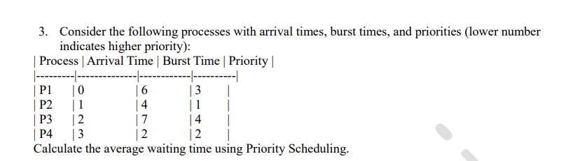

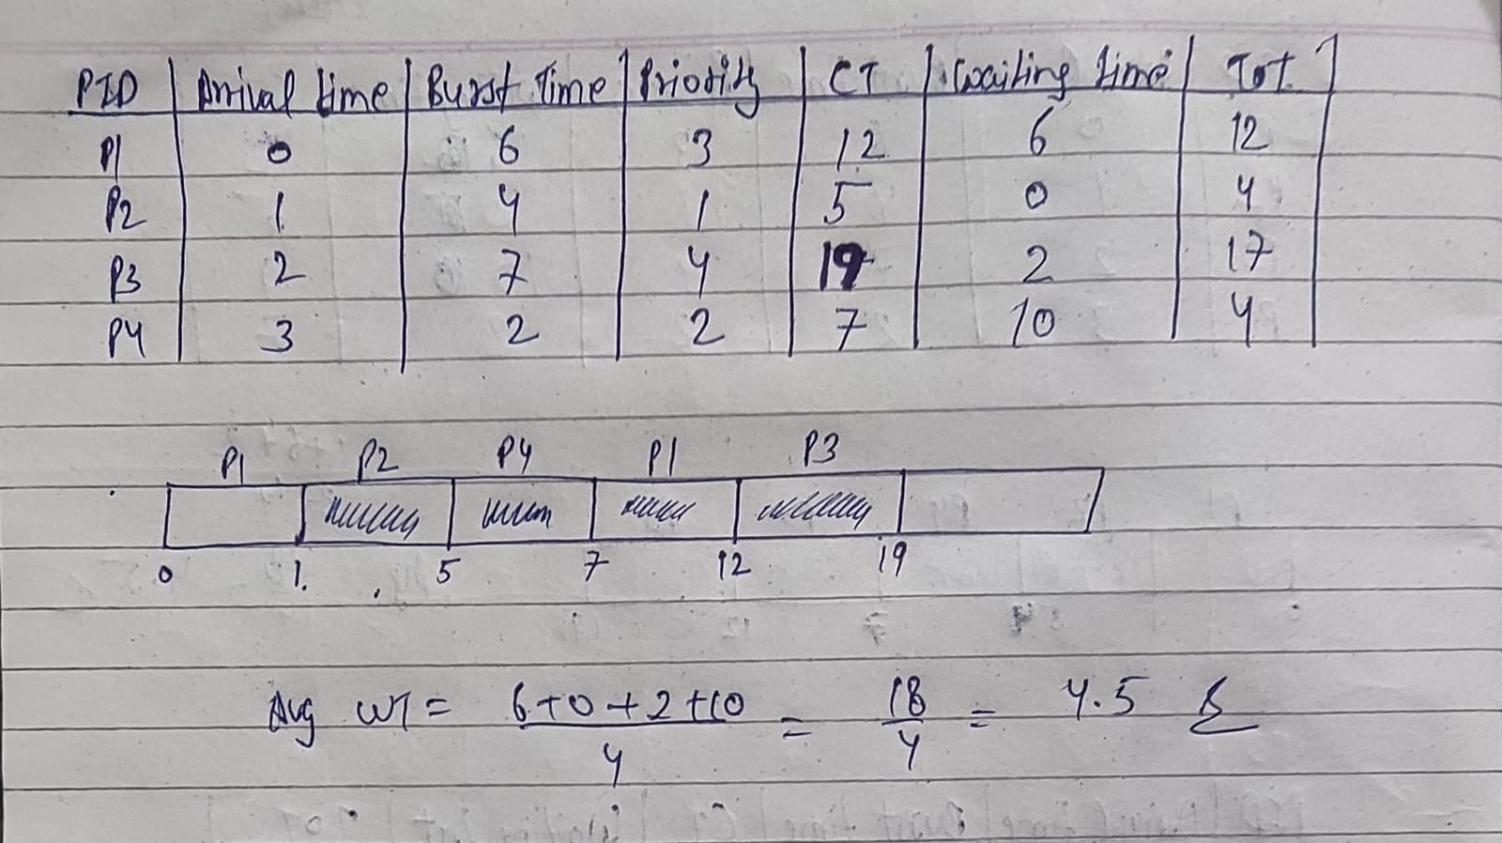

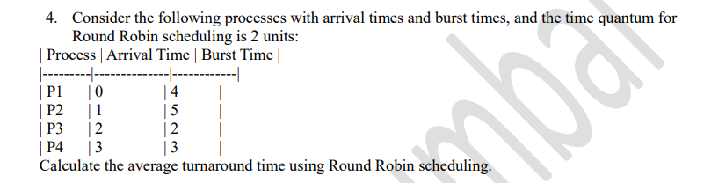

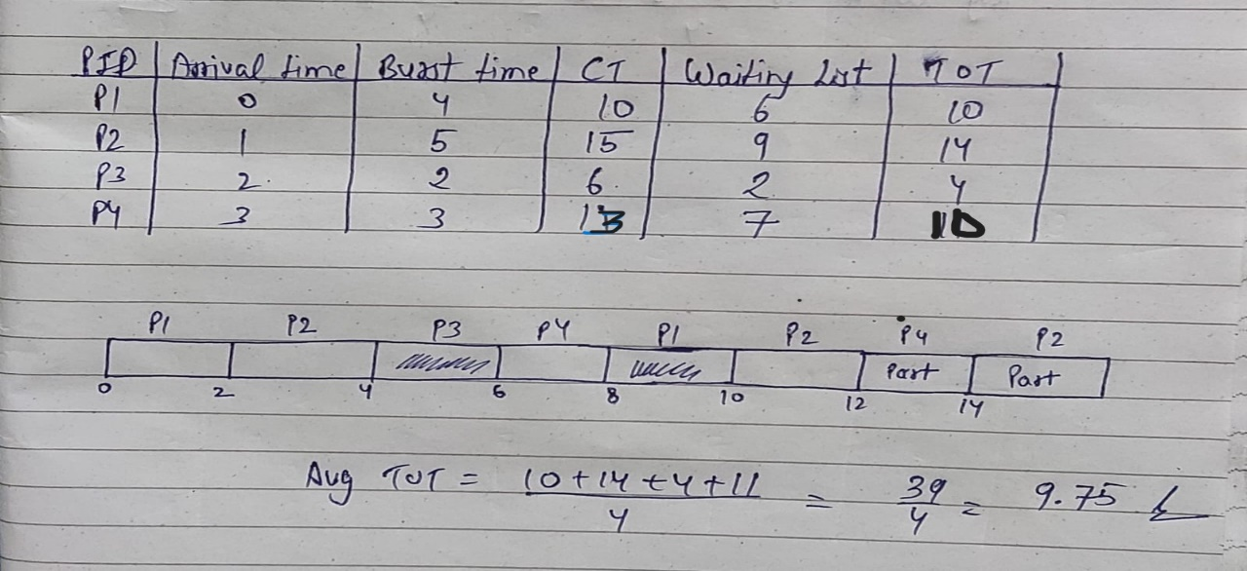

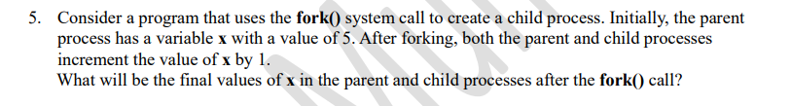

Answer is 6.